scopelab.ai



**Last Update: May/15/2020**

This report is created to explain the process of creating a graph using INRIX

The codes are available [here](https://github.com/StatResp/data_join_pipeline/tree/main/graph).

Contact info:

[s.m.vazirizade@vanderbilt.edu](mailto:s.m.vazirizade@vanderbilt.edu)

[abhishek.dubey@vanderbilt.edu](mailto:abhishek.dubey@vanderbilt.edu)

# Introduction

Anything that works based on connection or neighborhood can be modeled as graph. A graph is made up of vertices (also called nodes or points) which are connected by edges (also called links or lines). In our projects, usually streets and their intersection are modeled as a graph.

Some of the most important terminologies are explained below.

* Vertex (Node, Point)
* Edge (Link, Line)

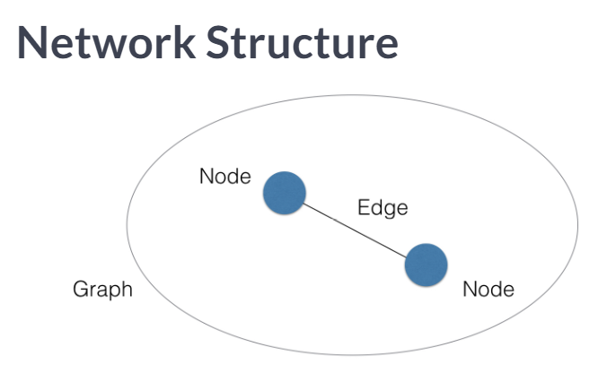

Figure 1 Structure of the Graph

In our projects, it is important to know which roadways are directly connected to each other and their sequence in the network. Therefore, we model our roadway network as a directed graph. Below, you can see graph generated by connected the highway segments (Nodes).

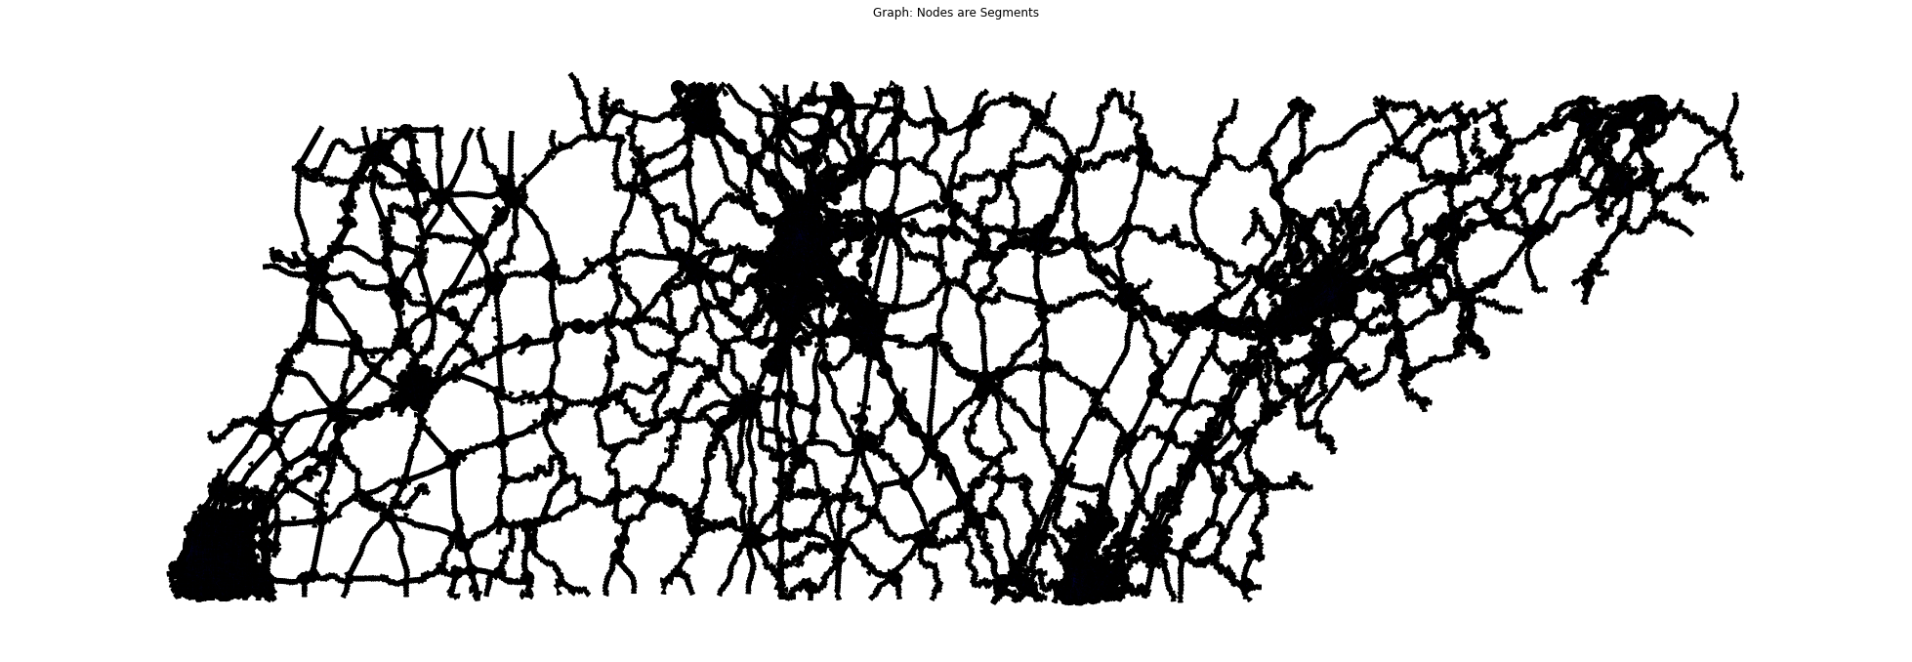

Figure 2 Nodes are (center of) highway segments and links show their connections

The segmentation of the highways is borrowed from INRIX. This dataset includes static data regarding the inrix segments. It contains shapefiles can be used to location of the segments on the map as well. Also, using a feature called FRC, the roadways segments are divided into various categories. Figure 4 depicts inrix segments color coded based on FRC. Also, Table 4 summarizes the features in the after cleaning. For further, information about features in INRIX, please refer to [this](https://github.com/StatResp/data_join_pipeline/blob/main/Pipeline.pptx). 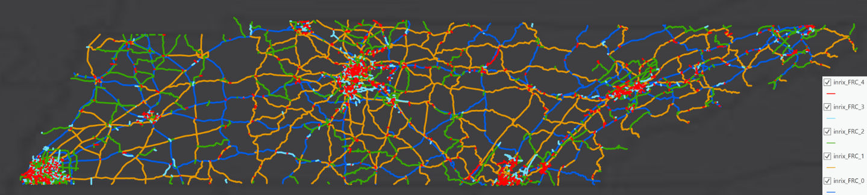

Figure Distribution of inrix roadway segments color coded based on FRC

# Creating the Network

As mentioned earlier, we consider the segments as nodes in the graph. If two (or more) segments share a point (the end point of one segment is the same as the beginning point of the other segment) a link connect those two (or more) segments. Please keep in mind, we aim to create a directed graph. The schematic process is shown in the figure below.

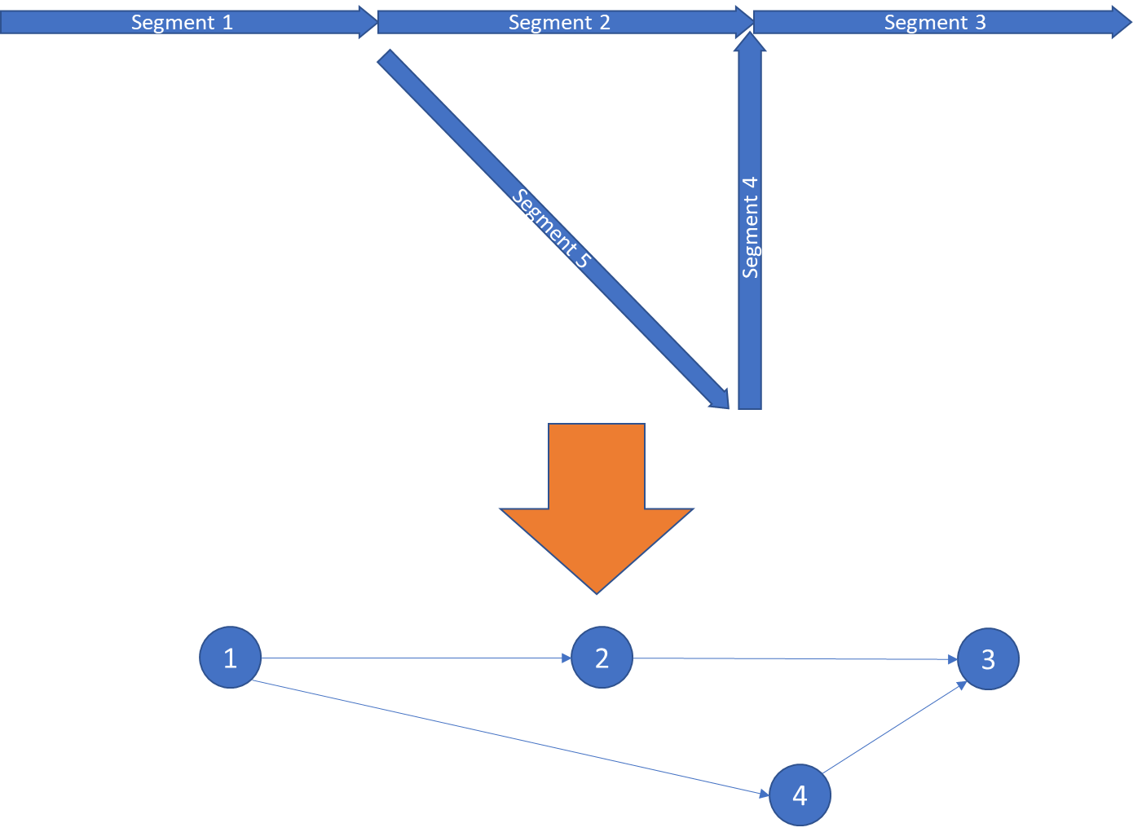

Figure Schmatic view of building a graph using segments

Furthermore, each row of INRIX dataset includes information about a roadway segment. Columns PreviousXD and NExtXDSegI, contain the segment id of the segment before and the segment after. We can also use this information to make sure if there are 2 segments located back to back, there is a link between them in our graph.

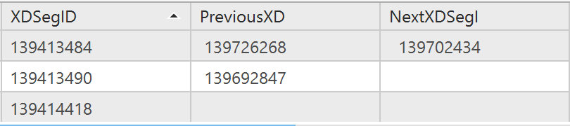

Figure Segment, Previous Segment, and Next Segment using INRIX

# Folders

inrix_graph_adj.json and inrix_graph_adj.pkl: these 2 files include the same adjacency matrix in 2 different formats.

inrix_graph.gpickle: this file includes the graph created by networkx. To open this file in python run Graph = nx.read_gpickle('inrix_graph.gpickle')

# Misc.

## Python Packages

* Networkx: It is the most common python package for modeling a network in python. <https://networkx.org/>
* Nxviz: it is a very useful package for visualizing the network. <https://nxviz.readthedocs.io/en/latest/>

## Useful Links

<https://www.youtube.com/watch?v=bpLIwUQKyrU>